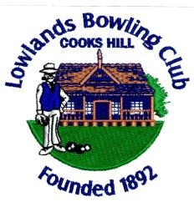
LOWLANDS BOWLING CLUB
MEMBERSHIP APPLICATION
Please print your details in block letters (*indicates a compulsory detail)
*Title ____ *Name _____________________ *Surname ___________________________
*Residential Address ________________________________________________ *Suburb_________________
*Post Code ________ *DOB _____________ *Occupation ____________________________________
*Email ________________________________ Mobile ________________________ Phone _____________
In giving the above contact details to us, you consent to the Club using any of these details as appropriate for Notices of AGMS and emails unless you notify otherwise.
Have you ever been suspended expelled or asked to resign your membership of any Club? Yes / No
Have you ever requested Self Exclusion from any Gaming Venue? Yes / No
SOCIAL MEMBERSHIP $10 Yes / No
MALE MEMBERSHIP $85 Yes / No Royal No ____________
LADY MEMBERSHIP $85 Yes/ No Royal No ____________
LADY TRANSFER FEE $25 WBNSW $8 NDWBA
To the Directors: I hereby apply for election as an Ordinary Member of Lowlands Bowling Club as the Membership indicated above. I declare I am 18 years of age. If elected I agree to be bound by the Articles of Association and By Laws for the time being in force (a copy of which is available at the Office )
I understand if I give false details on this form the Directors may reject this application or take disciplinary action against me under the Constitution. I authorise the Club to make reasonable enquiries regarding this application.
Applicants Signature __________________________ Date _______________
Full Lady and Male Membership nominations need 2 Full Members to sign:
Nominated By __________________________ Seconded by ______________________

*Applicants ID NSW Drivers License Number _____________________
Australian Passport Number ______________________

Address to Centennial Park 98A Dawson St Cooks Hill. NSW 2300
Email to admin@lowlands.com.au
Phone 0249293046 OR 0249262221
Fax 0249270433
Website www.lowlands.com.au

